


Dublin City Council
Flood Forum

Property Flood
Protection Guide

DCC Customer Services (Drainage) DCC Flood Forum
Tel: 222 0700 Tel: 222 3294

DCC Afterhours
Tel: 679 6186
Dublin City Council Flood Forum

Introduction

In October 2011 there was wide scale flooding across the Dublin City region that arose from very intense rainfall over a relatively short period of time. This intense rainfall caused rivers to flood and the drainage system to become inundated to such an extent that they over-flowed, causing flooding to streets, properties and to basements with shallow sewer connections. Over 1000 homes and premises in the Dublin City region flooded and many more gardens, car parks, streets and roads were flooded. Should this type of rain event occur again, these same homes and premises would most likely flood again. While the City Council continuously works to maintain and improve the existing infrastructure, the householders or property owners must also play a key role in protecting themselves and their property from flooding.
The City Council has set up a Flood Forum, which will provide support and information to communities that have been flooded or are considered to be at risk of flooding. The Forum works with communities as well as property-owners by providing community flood plan information, household flood plan information and relevant property protection information, as requested.
As a property owner, taking measures to protect your property from flooding will limit the distress and damage caused by flooding. Flood protection products may prevent your home/property from flooding but only to a certain limit. Most flood protection products are approximately 700mm high. As a general rule, the maximum height for any flood protection product fitted directly to a building should be no greater than 1 metre above the ground surrounding the building. Keeping floodwater out of a property where the depth of water is greater than 1 metre, can result in long-term structural damage to the walls and floors and could undermine the foundations due to the pressure which the water above 1 metre puts on the structure. Once floodwaters exceed approximately 1 metre in height, it is better to allow the floodwater into the house. Accordingly, you are strongly advised to continue to move valuables and furniture to a safe height (above ground floor level if possible) as water may still enter the property even when flood products are fitted.
For the individual property owner, finding the right flood protection product for any property that is at risk of flooding can be difficult. There are a variety of products on the market designed for many situations. The aim of this booklet is to show a small sample of products that are available, to enable you, the property owner/householder, to understand what each product does and to select the product(s) that best suit your needs. This guide was not designed to show every product available or to replace the information on the manufacturer’s web site.
It is important when buying a flood product that it has been properly tested – it should display the BSI Kite mark (this is a widely recognised symbol of quality for consumer goods) or an equivalent quality accreditation.

How FloodWater Enters Into a property

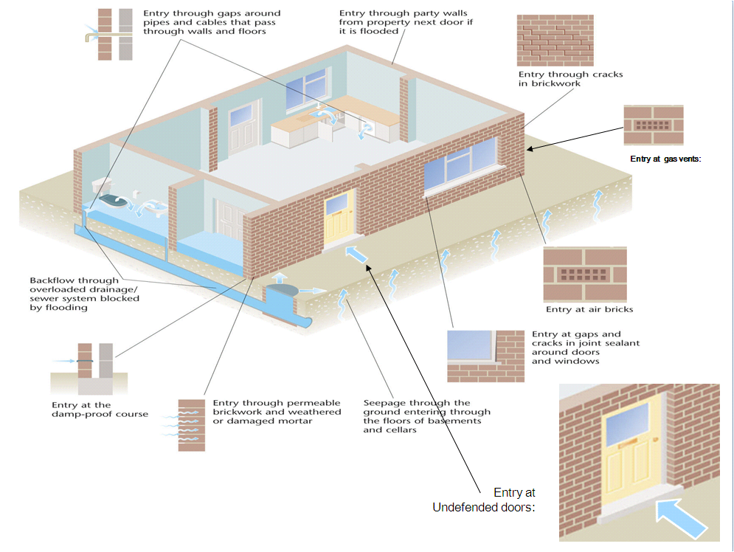
Doors, low windows, air bricks, broken brickwork, backflow of sewerage up through the toilet and ground water pushing up under the floor, are just a few of the many ways water can enter a property. However there is a lot that property owners/householders can do to minimise the entry of water into a property. That is the purpose of this booklet, to help and inform property owners/householders to see the types of products available and take action to prevent damage/injury during flooding.
Unless a house is detached there may be risk of flooding from adjoining houses through the dividing walls, gaps in under-floor walls or from adjoining private drainage. In light of this risk, it is recommended that householders of adjoining houses (semi-detached or terrace) consult with each other and install flood protection measures that will protect all the adjoining properties.

Flood Products – flood barriers
Very often, floodwaters enter a property through the doors of the property. Flood barriers are removable barriers that can be placed across doors in the event of a flood. There are numerous types of barrier available to buy – this booklet shows only a few of the types of barrier available. However, it is possible to make your own barrier and provided it is strong enough and it fits properly into the opening creating a watertight barrier then it should be effective in holding back floodwater. Barriers are available for pet flaps too.
Flood Resistant Doors
This flood resistant door is designed and manufactured with a special seal between the frame and the door, which effectively prevents water from entering the property. However, these types of doors are usually designed to fail (to allow water in) if the floodwater exceeds approximately 700mm otherwise there is a risk that the floodwater would cause long-term structural damage to the house. The door is designed to blend in with the property and there is nothing which would identify it as being an effective flood barrier. The main advantage of flood resistant doors is that when the door is closed the flood protection is immediately effective.

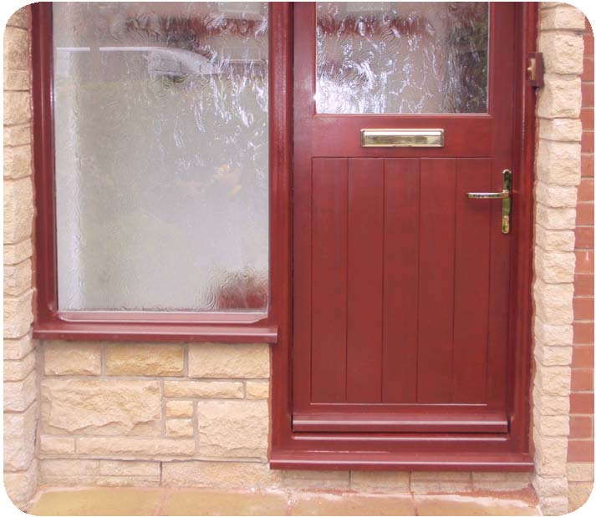

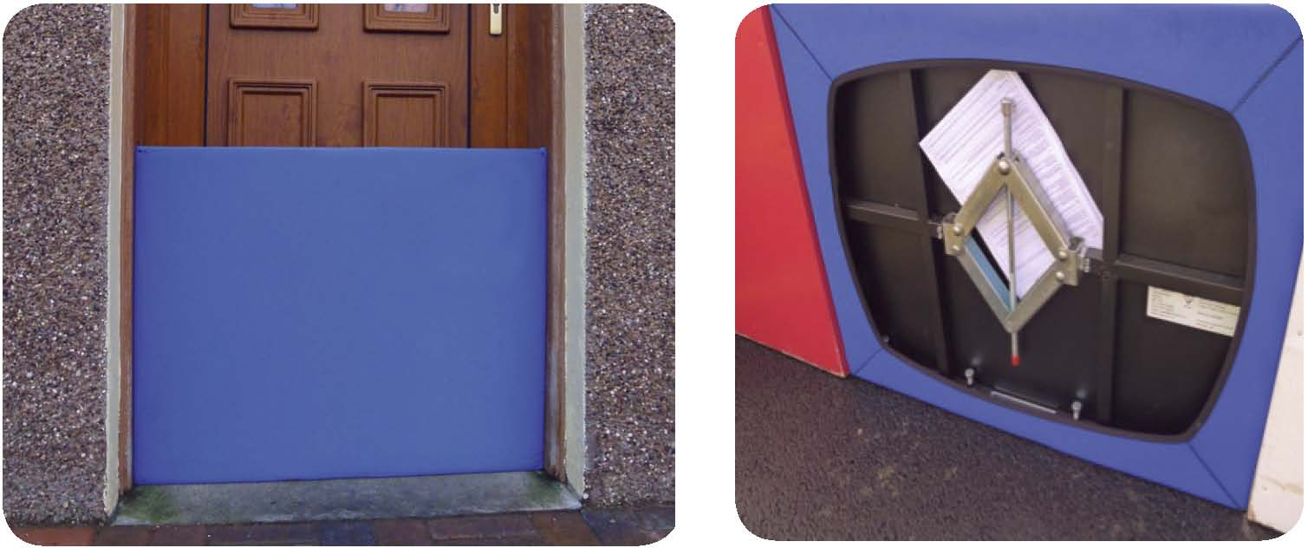
Door Barrier - expands to fit
The photo above shows an ‘expand to fit’ barrier. No frame is required, just a simple expansion system which allows one flood barrier to fit a number of different size openings. It is a very effective system, but the product can be a little heavy if used by someone who is physically impaired, such as an elderly person. The reverse view of this flood barrier is also shown above.

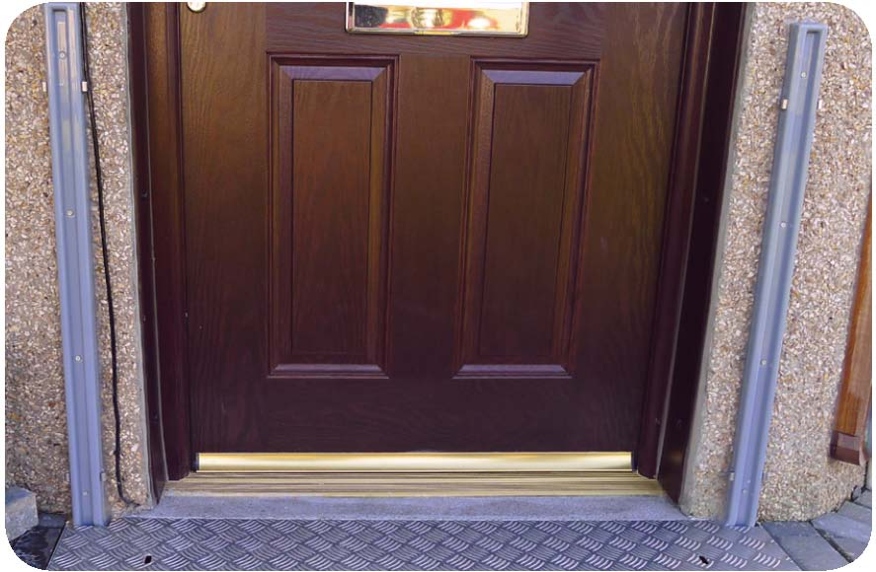
Door Barrier – Fitted to a frame
Generally this type of barrier has a frame that is permanently fitted to the door frame or wall and a separate water-tight panel that can be slipped down into the frame when needed. There is usually a neoprene rubber attached to the sides and bottom of the panel to ensure a water-tight seal.

DIY Barrier – Fitted to a frame
The photo shows a door barrier that was made by a householder in Dublin. The barrier has been effective in protecting the house from flooding. The householder made the frame around the outside of the door using shelving channels on the sides and a strip of insulating rubber along the base. The barrier is 20mm thick marine plywood coated with a waterproof spray (that is used for boats). The barrier also has rubber strips fixed to the sides and base. The barrier is made to fit very snugly into the frame. There are bolt holes at the top of the frame on both sides so that when the barrier is slotted into the frame, bolts are inserted into the holes to keep the barrier pressed down tight.

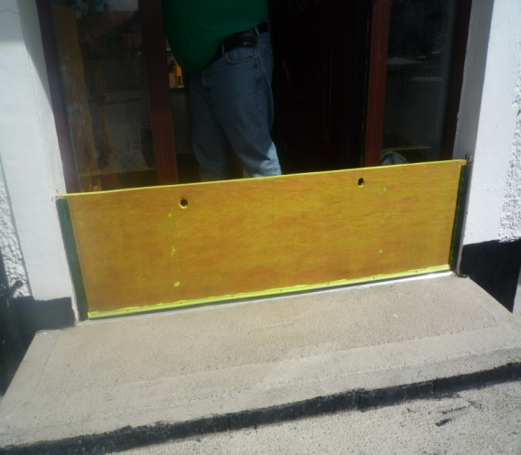

Sectional Door Barriers
Garages or wider opening are always more difficult to address when seeking to prevent flood water entering the property. The barrier shown here consists of 4 long panels stacked on top of each other, each one interlocking into the other, forming an effective barrier. Removal of the barrier allows the garage to be used by cars as normal. This type of barrier is also supplied in shorter lengths for standard door openings.

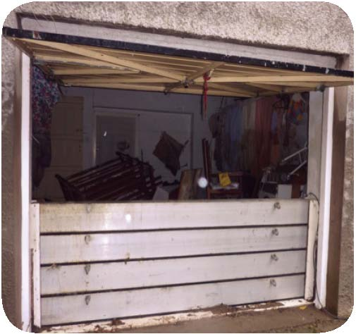

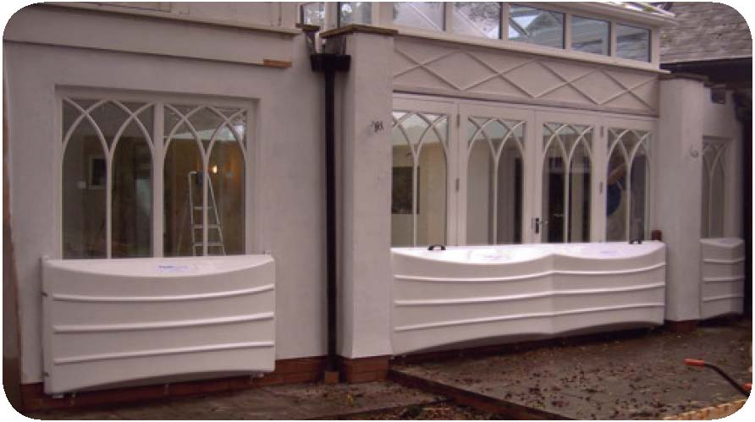
Conservatory Door Barrier
Conservatories are often more difficult to protect from flooding because of the span of the doors. These door barriers blend in well with the existing uPVC doors. The barriers and the pre-installed frames, into which the barriers are fitted, come in a variety of different colours.

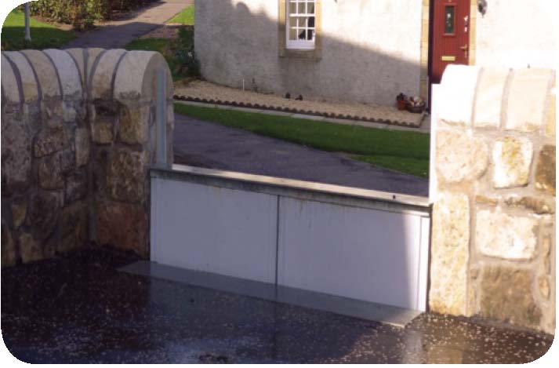
Gate barriers
The further back floodwater can be kept from a house the better. Gate barriers can be very effective provided the surrounding boundary walls are structurally sound.

Flood Products – air brick covers

Any house that has a void under the ground floor is likely to have air bricks or air vents at a low level in the walls. The purpose of the air brick is to allow air to ventilate the underside of the floor, thus avoiding rot to the timbers due to lack of ventilation. Air-bricks should only be covered for short periods of time during an expected flood event. Otherwise they should be left open to allow for air circulation. There are several types of air brick cover on the market – some are permanent and do not require the householder to do anything, whilst others require the householder to fit a cover or bung to a preinstalled unit before an expected flood. It is possible to make your own air brick cover and provided it is made strong enough and it fits properly over the vent or in place of the vent, then it should be effective in holding back floodwater.

Automatic Air Brick
This type of airbrick is designed to replace the existing air brick that is in your property. This air brick has a clever floating ball arrangement which seals the ventilation hole when flood water reaches the airbrick and opens it back up when the floodwater subsides. Some manufacturers use a flap valve instead. Although more expensive than some products, it has the advantage of working even if you are away from the property.
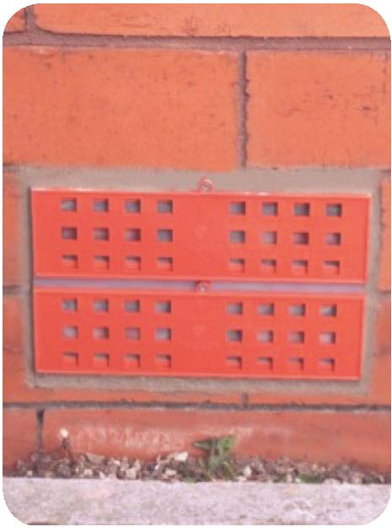

Permanent Air Brick Cover – Snorkel
This is another permanent air brick cover. The snorkel air brick cover is permanently fixed to the wall over the air brick. The snorkel has vents at a high level that still allows ventilation yet prevents the entry of floodwater. This type of cover is very effective on vents which are close to the ground. They come in a variety of different heights.
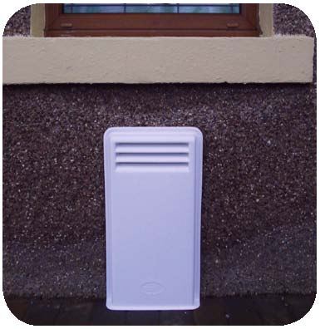

DIY Air Vent Cover – Snorkel Type
The photo opposite shows a DIY snorkel-type air vent cover. The existing air brick was broken out. A 2½ inch downpipe with elbows was slotted into the gap where the air vent was. The gap around the pipe was closed up using bricks and then rendered with a waterproof compound. This air vent also has a rubber seal twist fit cap that can be fitted in flood conditions to completely seal the vent. The cap is left off in normal conditions to allow for ventilation.
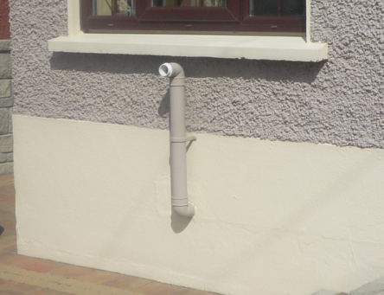

Air Brick Cover– Permanent
This type of air brick cover is permanently fitted to the wall and it can be painted. There are two expanding bungs, which are fitted into the holes (black) near the bottom of the cover. During normal weather the holes are left open to allow ventilation, but during an expected flooding the bungs need to be fitted into the holes by the householder to prevent water getting in.
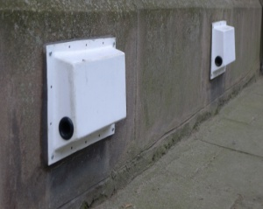

Air Brick Cover - with clip on cover
This type of air brick cover works by fixing a secure frame directly onto the wall around the air brick. The frame is permanently left in place. When there is a possible flood event, the cover will need to be fixed onto the frame (usually using clips or screw fixings) and that will prevent flood water entering the property through the air brick. The cover will have to be removed again after the flood to allow for normal ventilation. The picture here shows a white air brick, the blue frame has yet to be fitted to the wall around the airbrick and the red panel is the cover that can be clipped onto the frame.

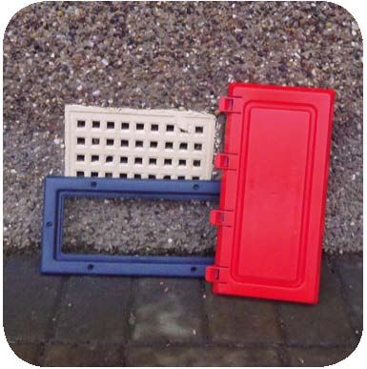

Flood Products – Pipe Non-Return Valves & pumps

Valves and pumps are particularly useful for protecting properties with basements or low-level ground floors. Flooding can arise in these types of properties where the pressure of floodwater in the drainage infrastructure may force sewage back into the property via low-level sewer connections. Under normal conditions, there is generally a shallow depth of water flowing through the public sewer to which your property is connected, allowing wastewater from the property to flow out through the private drain pipeline to the public sewer. However, in extreme rainfall events, the water level in the public sewer can rise as the sewer fills with rainwater. Depending on the depth of the basement or ground floor and the depth of the adjacent public sewer, the water level in the sewer can rise above the floor level in the property. Once this happens, the property will start to flood.
In order to provide effective protection, a non-return valve should be installed on the private drain pipeline, as close to the public sewer as possible. Where there is more than one private drain connection serving the property, each pipeline will have to be individually protected. Depending on the existing private drainage arrangements, a new manhole on the private drain pipeline may be the best place to locate the non-return valve(s).
Non-return valves prevent water from the public sewer entering the private drainage system of the property. However, if rainwater from the roof and courtyard/garden areas of the property is connected directly to the household private drainage system, this rainwater cannot escape while the non-return valve is closed. The rainwater then builds up in the private drainage system and can cause flooding of the property. Likewise the use of toilets, sinks, showers, baths, dishwashers, washing machines etc. during flood condition (while the non-return valve is closed) can cause flooding of the property.
This cause of flooding can be controlled by not using toilets, sinks etc during flood conditions and also by redirecting the roof gutters and downpipes to discharge elsewhere, so that this water does not collect within the property. A suitable point to discharge water to would have to be identified. An alternative to redirecting the roof gutters and downpipes would be to fit a pump upstream of the non-return valve. A correctly installed pump (or pumps) could lift the rainwater to street level and discharge it to the footpath. Ideally, the pump should be automatic and housed in a below-ground chamber. However, a manual pump set up by the householder at a low point in the garden would be sufficient.
The design of a non-return valve and pump system would have to be carefully considered to ensure that it activates at the appropriate time, and does not cause water to run into adjacent properties. The design of such a system would depend on the site details, and should be carefully considered. It is advisable to seek the professional services of an architect/engineer if in doubt. Maintenance of pumps and non-return valves is also important to ensure their continued operation.
The following Dublin City Council website link provides information on basement flooding: http://www.dublincitybid.ie/wp-content/uploads/2012/01/Basement-Flooding-Leaflet.pdf

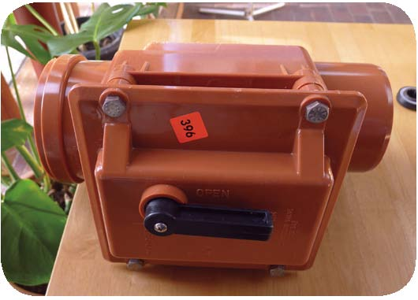
Sewage Non-return Valve
Keeping sewage from back-flowing into the property through the drains of the property is often overlooked. Flap valves or non-return valves like the ones shown here should be installed between the property drain and the public sewer. They need to be installed by a plumber and they need to be accessible for routine maintenance. Where possible use 2 non-return valves or a multi non-return valve to give extra protection.

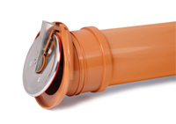

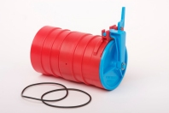

Sump pumps
Sump pumps are invaluable in removing water from the under-floor void of a property or from low points in gardens/courtyards. They can also be moved around to wherever water may be entering the property, which can prove much easier and much more effective than using buckets. In high risk flood areas, automatic pumps are often permanently fitted into a low level chamber and a water activated float switch allows the pump to remove water as soon as it reaches a fixed depth. In general a pump with a pump rate of 100 -200 litres per minute should be sufficient for dealing with household flooding. Always use a pump with a RCB circuit breaker safety switch to prevent any danger from water coming into contact with electricity. It is also advisable to fit, or have fitted by a suitably qualified electrician, an outdoor electrical socket in an area where it would be unlikely to be affected by a flood, preferably more than one metre above ground level. If possible, the socket should have its electrical supply taken from the upstairs circuit because you may need to switch off the downstairs electrical circuit if water is entering your house.

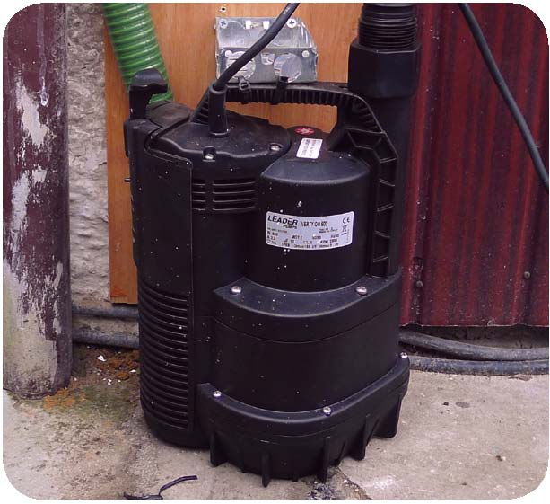

Flood Products – bungs & Small Valves
Inflatable Toilet Bungs
In flood conditions sewage can back-flow directly into your home through the toilet, especially if you have a basement or ground floor toilet. Toilet bungs are placed into the U bend, where they are then inflated using a pump, which prevents sewage back flowing into your home. An alternative to the toilet bung is to install a push-fit non-return valve into the outlet pipe if you have access to it from an AJ outside your house.

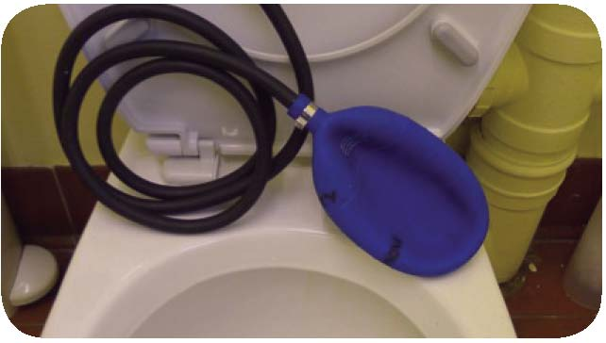

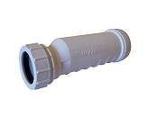
Non-Return Valve for Small Pipes
Floodwater can enter a house through low level pipes for sinks, showers and baths etc. as well as washing machines and dishwashers. Small non-return valves should be fitted to these outlet pipes to prevent floodwater getting in.
Pipe Bungs
In some cases, small non-return valves may not be suitable – pipe bungs are an alternative. They require the household to close off the pipes by pushing the bung into the pipe during flood conditions and removing it afterward. Appliances, sinks, showers etc should not be used when bungs are fitted to the outlet pipe.

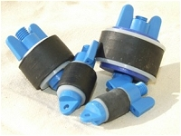

Flood Products – Sandbags & Synthetic Sandbags
Conventional Sandbags
The picture says it all – even with conventional sandbags put in place the homeowner still has to pump water out of the house through the letterbox. Sandbags are difficult to deploy and they are not waterproof. Should they come in contact with floodwater, they tend to retain contaminants such as sewage which means they are difficult to dispose of. Sandbags can be effective in keeping floodwater from entering a house when the floodwater is marginal but in relation to large volumes of water they are largely ineffective. If it is your preference to use sandbags then you should keep a stockpile of them at your property and when you use them, lay sheets of plastic under and up the back of your stack of sandbags. Please be advised that Dublin City Council does not provide or distribute sandbags to individual properties or premises.

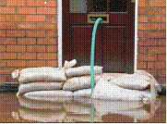

Synthetic Sandbags
These are modern alternatives to conventional sandbags. They are lightweight, easily stored and deployed, and some are re-usable. They are also significantly more water-proof than conventional sandbags. They contain a special polymer that is activated by immersing in water for a few minutes and they can be moulded to fit the location where they are to be used. However, they tend to have a shelf life of above 5 years (even if they were never used) – homeowners should check this before purchasing

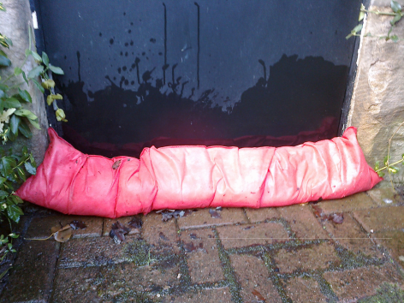

Flood Products – Tanking

Tanking is a construction industry term for coating or lining walls to help keep an underground structure, such as a basement, free from water. There are two basic types of tanking – external and internal. In general, external tanking is used when a basement is being built and internal tanking is used where a basement is already built. External tanking usually involves applying a waterproof membrane around the outside of the underground structure and the membrane prevents water seeping in through the structure, particularly at joints where walls and floors meet. Internal tanking usually involves some form of drainage that will funnel any water that comes through the walls and/or floors to a low point where a pump is installed – the pump then ejects the water through a pipe out of the basement.

Tanking is not just for basements. External tanking may be an option worth considering for houses (with or without basements) that are in areas that flood. If floodwater is sitting against a house for even a few hours it is likely that the water will begin to penetrate through the walls. There are products available that can be applied to the external walls that will prevent/reduce water penetration.

If tanking is being considered then advice should be sought from reputable tanking specialists.

Flood Products – Miscellaneous

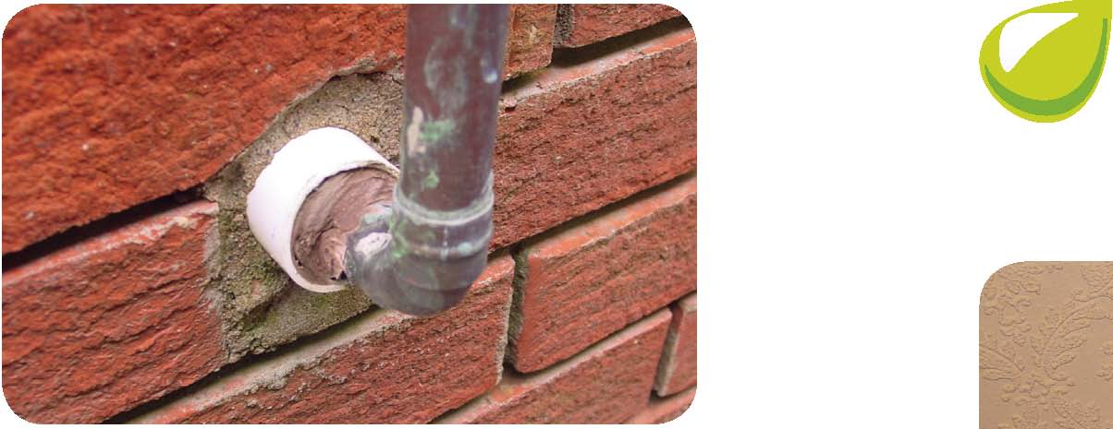
Seal Gaps Around Pipes & Cables
Floodwater can enter through openings around any pipes that go through walls. For this reason, you should seal gaps around pipes with water-proof mastic or silicone sealant. Don’t forget to check on your gas/electricity boxes and seal around cables, especially if they are at a low level.

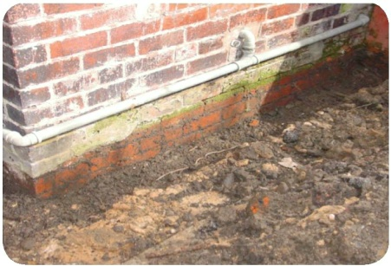
Repair Cracks in Walls
Cracks in walls provide a direct path for floodwater to enter a property. Cracks below the expected maximum flood level should be repaired. The repair should be carried out by carefully filling the crack with a suitable water-resistant product that will adhere to both crack surfaces.

Audible Alarm
This is generally a battery powered alarm that can be placed in a property. When the flood water reaches that point the alarm is triggered giving you a warning of floodwaters on your property. Some types of alarm emit a loud tone similar to a smoke alarm, whilst others trigger a remote alarm, for example in the house. Audible warning alarms are especially useful if flooding occurs during evening/night time hours when you may not notice floodwaters or you may be asleep in your property.

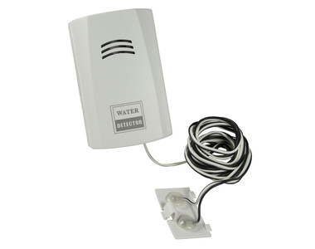

Useful websites

For information on flood protection product suppliers and on indicative costs of products please go to our website www.dublincity.ie

The website also has other relevant flooding information including: Basement Drainage, DCC’s Sandbag Policy and a guide for householders on Household Flood Plans

The following websites also contain useful flood information:

www.flooding.ie

www.floodmap.ie

www.ciria.com/flooding/advice_sheets.html

www.bluepages.org.uk

About this document
This document may be updated from time to time – please refer to the DCC website (www.dublincity.ie) for the most up to date version.
The property flood protection products shown in this booklet are for illustrative purposes only. The inclusion of any product in this booklet does not imply any endorsement of the product by Dublin City Council. Due to the wide variety of possible locations which flood protection products could potentially be used in, Dublin City Council gives no warranties as to the quality or suitability of the flood protection products and excludes, so far as may be allowed by law, any warranties express or implied by statute, common law or otherwise.

Acknowledgement
Dublin City Council wishes to thank the Scottish Flood Forum for their advice in establishing the Dublin Flood Forum and for all the documentation and guidance that they provided.

